Mobile phone technology and its possible future application in the field of education in Kenya

Technology Futures
M Phil. Futures Studies
J.A.C. Bezuidenhout
16035437
Development Bank of Southern Africa
1258 Lever Road, Headway Hill
MIDRAND
1685
Tel: 011 313 3546
Cell: 0788026137
Martin Butler
29 July 2011

DECLARATION:
I herewith declare this work to be my own, that I have acknowledge all the sources I have consulted in this assignment itself and not only in the bibliography, that all wording unaccompanied by a reference is my own, and that no part of this assignment can be found on the internet, any published source, or in any other document that has been submitted to any university in partial of full satisfaction of the requirements for a subject of course or degree.
I acknowledge that if any part of this declaration is found to be false I shall receive no marks for this assignment, and I shall not be allowed to complete this module, and that charges can be laid against me for plagiarism before the Central Disciplinary Committee of the University.

SIGNATURE: 7404295258088

KEY CONCEPTS

D-learning (distance learning) “offers students the opportunity to work or stay at home and study course materials when they find it convenient. Course materials took the form of printed material sent by post. This called for improved road and rail transport especially to marginal areas. Advancements in information technology in the 80s, lead to the introduction of audio-visual aids, cable and satellite that further enhanced the learning experience.” (Mobile Education, a glance at the future: 2003)

E-learning is “analogous to online education. Paulsen and Keegan et. al. (2002, p. 23) provide the following definition of this form of education:
“Online education is characterized by:
• The separation of teachers and learners which distinguishes it from face-to-face education
• The influence of an educational organization which distinguishes it from self-study and private tutoring
• The use of a computer network to present or distribute some educational content
• The provision of two-way communication via a computer network so that students may benefit from communication with each other, teachers, and staff”. (Mobile Education, a glance at the future: 2003)

M-learning “is learning that can take place anytime, anywhere with the help of a mobile computer device. The device must be capable of presenting learning content and providing wireless two-way communication between teacher(s) and student(s). Typically, an educational organization administrates both the course content and the communication services” (Mobile Education, a glance at the future: 2003)

INDEX Page

- Introduction 4

- Environmental scan 5
2.1. Political 5
2.2. Economic 5
2.3. Social 6
2.4. Institutional 7
2.5. Natural Resources 9
2.6. Technology
2.6.1. Mobile phone access 9
2.6.2. Software 10
2.6.3. Hardware 10

- Exploratory and normative forecast 11

- Conclusion 12

BIBLIOGRAHY 13

- Introduction

The majority of effort with regards to information and communication technology in lesser developed countries will inevitably focus on decreasing the digital divide with more developed countries. The rapid increase in the usage of mobile phones on the continent, wireless networks and the convergence of mobile phones into mini computing devices, such as I-phones and operating systems such as android, provide an ideal opportunity in this endeavour. This prompted the question of what role mobile phone technology, along with other enabling technologies will or could play in a crucial field such as education?

To provide additional context and focus, a specific country with unique conditions, Kenya, was chosen. The original reason for selecting Kenya was a selfish one. The writer of this assignment is also currently busy with a research report on the future of local government in Kenya and selecting Kenya for the technology research report would contribute to the outcome of both. As the literature were reviewed it became clear that Kenya could actually provide a close to ideal setting for M-learning and therefore a very relevant selection amongst other countries in Africa. Additional information will be provided during the course of this assignment.

To answer the question the following approach will be taken:

In the first instance a brief environmental scan will be done of political, economic, social, institutional and natural resource factors that might impact on the use of mobile phone technology in education in Kenya. The technological environment will be given more detailed attention.

One of the key concepts of futures studies is the art of conjecture, the ability to conjure up an image of a positive outcome and then studying the actions that might bring about that outcome (De Jouvenel). In line with this notion, in the second place, an ideal scenario will be sketched of what could transpire within the next five and ten years. Other contributing factors will also be discussed. Focus will be on the appropriateness of the technology. Often technology drives change and not the functionality required or appropriateness (Anton Spath: 2011). Especially in a crucial and sensitive field such as education one should be sure not to make use of a blow by a hammer to form a clay sculpture.

- Environmental scan

  - Political

After the elections in May 1963, won by the Kenyan African Union (KANU) under the leadership of Jomo Kenyatta, Kenya became independent in December the same year. It was declared a republic in 1964. Kenyatta became increasingly autocratic from the beginning of the 1970’s. After Kenyatta’s death in 1978 Daniel Arab Moi followed also becoming increasingly oppressive and eventually declaring Kenya a one party state. In1992 Kenya became a multi-party democracy once again. On all accounts corruption was endemic under his administration, being personally implicated in a major financial scandal. Mwai Kibaki followed in 2002, with a variety of complicated coalitions (Michael Jennings: 2008).

A recent significant event was the disputed elections that took place in 2007. Ethnicity as well as religious and generational difference played a role: those below the age of 35, mainly supporting Raila Odinga, and those above 50 supporting Kibaki. Violent clashes broke out in December 2007 and January 2008. Only by the end of February 2008 a settlement was reached between Odinga and Kibaki, with the intervention of the former United Nations Secretary General, Kofi Annan (Michael Jennings: 2008).

The adoption of a new constitution that provides for clear separation of powers is viewed as a major tipping point in Kenya’s political history. A BBC journalist writes the following comment after the promulgation of the new constitution in 2010: “the nation that is about to be reborn is far wiser than the one that emerged at independence almost half a century ago.” (Peter Grest: 2010).

If the next elections in 2012 go well, the current outlook, politically, is positive. Previously, conditions for investment in the application of a new technology such as M-learning in the field of education could not have been good. Now, there seems to be a general spirit of renewal in Kenya: a country that is eager to progress after a major political weight that was resting on their shoulders had been shed.

  - Economic

A report by the Poverty Reduction and Management Unit: Africa of the World Bank also states that Kenya might be at a tipping point, with sustained economic growth of between 5 and 6% for 2012 (World Bank: 2010). The following paragraph, with reference to M-pesa, from the report shows how fertile the ground within the ICT field, and especially mobile technology, is in Kenya:

“Today, Kenya has the largest mobile money platform in the world. An estimated 15 million mobile phone users are expected to be using mobile money by end 2010, the equivalent of three out of every four adult Kenyans. Kenya has positioned itself to become a global ICT hub, attracting investors who want to extend the ICT revolution domestically as well as look for applications in other developing countries.” (World Bank: 2010).

Overall Kenya needs to decrease its dependence on tourism and agriculture as a major export commodity. The establishment of a common market and free trade with its neighbours through the East African Community (EAC) and the Common Market for East and Southern Africa (COMESA) could provide further impetus for investment in the ICT sector (African Economic Outlook: 2011).

  - Social

Kenya’s rapid population growth and age structure in relation to that of its former colonizer, the United Kingdom, is demonstrated in the following graphs.

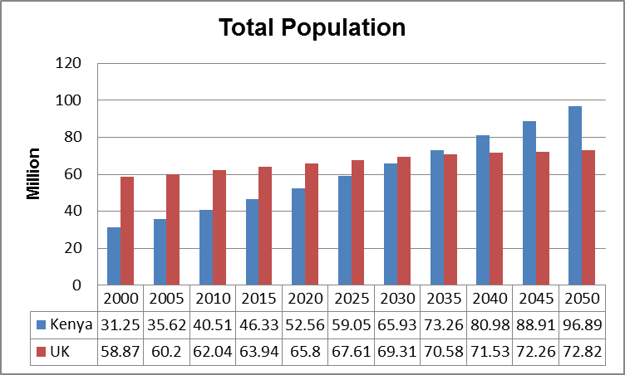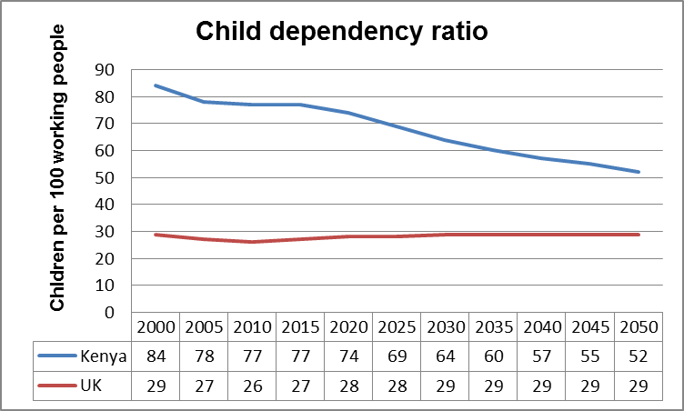
World Population Prospects: the 2010 Revision.

By 2030 it is forecasted to add an additional 25 million people to its current approximate population of 40 million and by 2050 forecasted to have more than doubled its population to 96 million. Major expenditure would be required on additional educational infrastructure such as schools and human resources such as educators and management. What are the possibilities of channelling some of that investment into M-learning as a replacement or augmentation for expenditure on infrastructure and additional human resources? As it is, Kenya has a shortage of four educators per school (Reference). Is it possible that more people could become employed as, for instance, data capturers and ICT technicians and network administrators maintaining a comprehensive M-learning system than brick layers building schools?

The possibility of a home environment, with fewer people in, that could be conducive to distance, M-learning might increase. The number of people per household will most probably decrease. The significant forecasted decreasing child dependency ratio means that adults will have fewer children to provide attention to in the future. Smaller families might cause better quality of interaction between children and parents, who are both more educated than before. The possibility of managing mobile phones/pda’s with additional capabilities such as web browsing, streaming and accessing audio, video and written materials also increase.

Due to urbanisation, smaller cities of populations between 100 000 – 400 000 could also become the order of the day (World Bank: 2010). This places economies of scale for the implementation of faster and better wireless networks within the reach of cell phone companies and other service providers.

What would be the reasons against? As stated earlier: education is not something that can be seen in a one dimensional, technology driven way. One would have to assess the unintended consequences, should it become technologically feasible to have children learning from home through video interaction and accessing learning material electronically.

Kenya’s current youth literacy rate (% of people with age 15-24) is 93% and its adult literacy (% of people with age above 24) rate is 87%. This stands out amongst the countries around it and also points towards a possible tipping point.

  - Institutional

A key ingredient, for the successful use of M-learning is the capacity and capabilities of the educational institutions in the country. What is their capacity to put together and manage an M-learning system? The digital divide not only relates to the usage of information and communication technology by the learners, but also the uptake and ability by those who provide and manage education in Kenya. The most recent report, that was found on ICT within the field of education dates to the year 2005. It is titled: National ICT Strategy for Education and Training – Kenya Educational Ministry 2005. The following are some of the key challenges:
“…the limited and uncoordinated approach to imparting appropriate ICT skills and competencies to teachers remains a major barrier in the integration of ICT in education in Africa generally, and in Kenya in particular.” (Kenya Educational Ministry: 2005)

“Currently, there is limited capability for effective use and maintenance of ICT infrastructure at the educational institutions. Most schools use less than 40% of the available ICT infrastructure and therefore there is need to ensure optimum use of ICT resources by students, teachers and administrators in order to exploit the educational potential of the technology. Furthermore, very few schools are using ICT as an alternative method for the delivery of the education curriculum.” (Kenya Educational Ministry: 2005)

The assumption is made that the above two challenges would be more relevant within the field of fixed line internet access and E-learning. A move towards M-learning on mobile devices accessing the web wirelessly could decrease these challenges over time as it might require less infrastructure.

The next challenge mentioned remains the same for both e-learning and m-learning. It could also be a major provider of employment opportunities if the correct investments are made.

“It is recognized in various documents that the national curricula developed at the Kenya Institute of Education (KIE) needs to be transformed from text to digital format in order to facilitate integration of ICT in delivery of education programmes. It is also recognized in the EPF that there is limited technical expertise and infrastructure for transformation of the national curricula to digital education curricula. It is also recognized that education software are varied and obtained from various manufacturers. The principal challenge therefore is to customize or develop education software to meet local education requirements in teaching, learning and administration. A much more important and critical component is the licensing of education software and related costs, which are prohibitive given the high levels of poverty in the country. Furthermore, most textbooks, particularly local published ones, are not available in a digital format and are consequently not available for use in digital media.” (Kenya Educational Ministry: 2005)

A further possible solution is mentioned: “The overall objective for ICT development in this component is to foster a favourable environment and provide leadership for public/private/development partner collaboration. This would lead to effective sector-wide ICT initiatives and coordination.” (Kenya Educational Ministry: 2005)

Mobile phone devices, with increasingly user friendly web browsing and operating systems, only became available in the past couple of years. With regards to the above one could see the possibility for cell phone companies and network providers to form partnerships with the department of education to enable M-learning that will provide additional revenue streams to them in the form of data usage and through the sale of mobile devices.

  - Natural resources

The production and distribution of text books is a major strain on the environment. The increasing use of digital resources could provide an alternative. Statistics points out though that many people still print out documents they receive access through email or the web. Future developments in mobile phone telephone technology could provide for roll out screens on which one could make handwritten notes, possibly decreasing the desire to print documents.

  - Technology
    - Mobile phone and internet access penetration

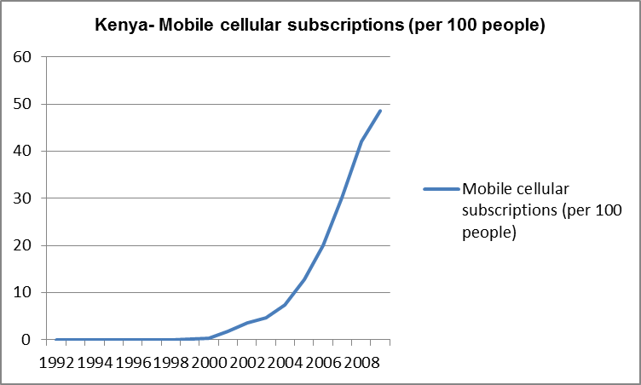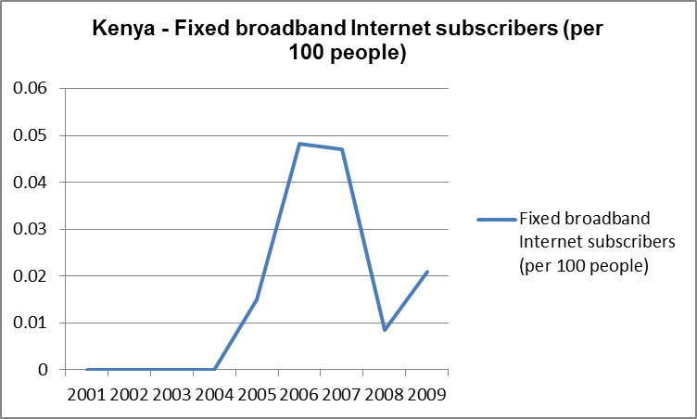

Source: World Development Indicators Database

Fixed broad band internet subscribers in Kenya remain below 1 out of each 100 people, whilst the use of mobile phones skyrocketed to more than 50 per 100 in 2009. It is clear that mobile phone devices with wireless access to the internet will become the method of accessing the World Wide Web and other online resources. No clear indication of the amount of people who currently actually use the internet on their mobile phones was found, but with recent developments, such as the android operating system and touch screen devices, it is quite possible that this rate will very soon increase rapidly as well.

    - Software

It was forecasted in the late 1990’s that the ability to browse the web successfully would have a major impact on ones’ ability to interact with the World Wide Web. The advent of search engines made this much easier than before. A popular term: “apps” are currently used to describe the access points that make interacting with the worldwide web on mobile devices easier for initial users. “Apps” could be developed for instance as access points to various subjects such as Maths Standard 6 or Physics Standard 8. Access to digital school libraries, purchased through “Kindle” could diminish the need for learners to carry around heavy text books.

    - Hardware

Mobile phones became one of the key points of convergence for several technologies over the last decade. They have cameras; can play video and access the web. Touch screens made browsing much easier. Moving and swinging apps around on screens is becoming common place and increase the user friendliness of devices. Future forecasted developments are improved and larger fold out or roll out screens, possibly also projecting the screen of the mobile phone.

A couple of pictures of forecasted future developments were sourced from the web:

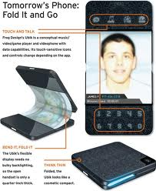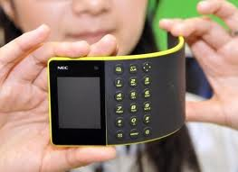

- Exploratory and normative forecast

2015

At this stage the use of mobile phone technology might be limited to the use of mobile phones for communication purposes, providing information such as rosters on mobile sites for tertiary education institutions. Parents of children in primary and secondary education are sent updates about major school events, fundraisers, progress of their children. Some private institutions are experimenting with short video clips that can be accessed by mobile phone to explain more complicated aspects of subjects within science and maths. The benefit being that the students can pause and restart the clip at instances where they are not able to follow the pace of the lecturer. Multiple choice exams are done on mobile phones in exam centres where the mobile phones are prohibited from browsing the web during the session.

2020

M-learning as defined could be active. Mobile devices at this stage are either able to project images large enough or can be folded open or extended to become large enough to have a screen that is user friendly enough to show an interactive video based class room session. Secondary education and tertiary education takes place mainly through pre-recorded sessions for all subjects and modules. Some learning centres are available for question and answer contact sessions, but large amounts of the secondary school and tertiary education students access their classes through the use of a mobile device, at their own time(within the time frames dictated by exams) in a setting of their choice. Learning centres for contact sessions remains popular due to the possibilities of socialisation with other students and the sports clubs attached to it. Electronic reading and physical note making with a stylus like pen on the screens of mobile devices becomes a possibility and replaces the need for printed text books and paper hand outs, saving large amounts of natural resources. Multiple choice question exams are done through mobile devices and browsing can be controlled distantly, but written examination takes place at examination centres in medium sized cities spread over the country.

- Conclusion

Kenya seems to be at a key point in its history on many different levels. Within the ICT sector, the use of mobile devices for access to the web and education opportunities, could be provide the ideal springboard from which to cross the digital divide.

BIBLIOGRAPHY

Africa Economic Outlook: Kenya. 2010. From http://www.africaneconomicoutlook.org/en/countries/east-africa/kenya/, accessed on 20 June 2011.

Brown, Tom. H. 2005. Towards a Model for M-learning in Africa. International Journal on E-Learning, 4(3), 299-315. Norfolk.

Jennings, Michael. 2008. Kenya: Recent History in Africa South of the Sahara, 2008 Edition. Exeter. Routledge.

Späth, Andreas.2011. Call me a Luddite. From http://m.news24.com/news24/Columnists/AndreasSpath/Call-me-a-Luddite-20110504-2, accessed on 29 July 2011.07.29

Vanston, Lawrence.K. 2009. Practical Tips for Forecasting New Technology Adoption. Teletronic 3/4 . 2008.

World Bank, Poverty Reduction and Economic Management Unit. 2010. Kenya Economic Update: Kenya at Tipping Point – with a special focus on the ICT revolution and mobile money. December 2010. Edition nr 3. From http://siteresources.worldbank.org/KENYAEXTN/Resources/KEU-Dec_2010_Powerpoint.pdf, accessed on 20 June 2011.

Author unknown. Mobile Education: a glance at the future. 2003. From http://www.dye.no/articles/a_glance_at_the_future/theoretical_foundation_for_mobile_education.html, accessed on 20 June 2011.

